**Practice Leaflet**

**Modality Partnership**

**The Windmill Practice**

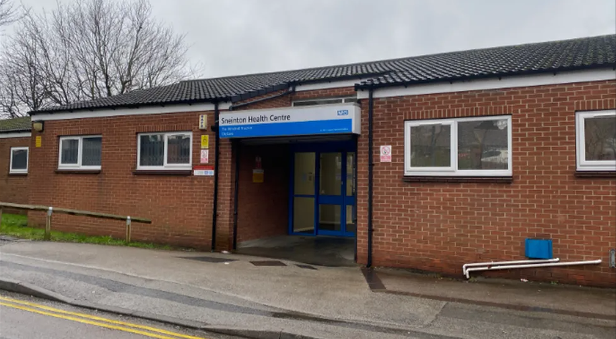

**Main Surgery**

The Windmill Practice

Sneinton Health Centre

Beaumont Street

Sneinton

Nottingham

Nottinghamshire

NG2 4PJ

Telephone: 0115 8838660

https://www.windmillpractice.nhs.uk/



**About Our Practice**

Welcome to The Windmill Practice

We are a group of general practioners providing General Medical Services for primary care operating under a traditional partnership model. We are proud to have a highly skilled multi-disciplinary team providing care for our patients. As a training practice our health professionals are involved in the education of GP Registrars, administrative practice staff and other healthcare professionals.

The Practice is a member of Nottingham City East Primary Care Network. This is a requirement of the contract under which we work to improve and build primary care services, and to meet the changing needs of the community.

The Practice is in the region of NHS Nottingham and Nottinghamshire Integrated Care Board. This is the statutory NHS organisation responsible for developing a plan for meeting the health needs of the local population, managing the NHS budget and arranging for the provision of health services in the Integrated Care System (ICS) area. More details can be found at [NHS Nottingham and Nottinghamshire ICS - NHS Nottingham and Nottinghamshire ICS (healthandcarenotts.co.uk)](https://healthandcarenotts.co.uk/)

NHS Nottingham and Nottinghamshire Integrated Care Board can be contacted at:

Sir John Robinson House  
Sir John Robinson Way  
Arnold  
Nottingham  
NG5 6DA

Telephone: 0115 8839570  
Email: [nnicb-nn.patientexperience@nhs.net](mailto:nnicb-nn.patientexperience@nhs.net)

**Meet our Team**

|  |  |  |
| --- | --- | --- |
| **Doctors** |  |  |
| Dr Lesley Cookson | General Practitioner | BM BS BMedSci MRCGP |
| Dr Austin Dekker | General Practitioner | MBBS BSc (Hons) MRCGP |
| Dr Daniel Haycock | General Practitioner | BM BS, BA (Hons), MRCGP |
| Dr Helen Hollis | General Practitioner | BMBS BMedSci (university of Nottingham 1987), JCPTGP (1991) DFSRH, LoC IUT, LoC SDI and FRT (Faculty Registered Trainer) |
| Dr Elizabeth Hughes | General Practitioner | MB ChB, MRCGP |
| Dr Karpagam Kamalanathan | General Practitioner | MBBS, DTM&H, MRCGP |
| Dr Charnelle Lusuku-Craven | General Practitioner | BMBS, BMedSci, MRCGP |
| Dr Emmanuel Olalude | General Practitioner | MBBS (Nigeria), MMedSci (Nottingham), MRCGP |
| Dr Helen Sperry | General Practitioner | MB BS (London), MRCGP  BA (Oxon), DCH, DRCOG |
| Dr Stephen Willott | General Practitioner | B Med Sc, BM BS, DGM, DCCH, DRCOG, MRCGP, DTM&H, MPH |
|  |  |  |
| **Nursing & Health Care Team** |  |  |
|  |  |  |
| Miriam Brown | Practice Nurse | B.Ed (hons), Dip HE (adult) Dip HE (child) and nurse prescriber |
| Emily Hardy | Practice Nurse | RGN |
| Heather Irwin | Practice Nurse | RGN, degree module in contemporary management in diabetes |
| Sally Riddle | Practice Nurse | RGN, Prescriber |
| Crystal Bowen | Phlebotomist |  |
| Rebecca Cheetham | Healthcare Assistant |  |
| Katrina Harding | Healthcare Assistant |  |
| **Allied Health Professionals** |  |  |
|  |  |  |
| Clare Lawson | Advanced Nurse Practitioner | RSCN, RGN, Prescriber, BA Health and Social Care |
| Shahid Sattar | Clinical Pharmacist | B.Pharm, PgDip (OSPAP), PgDip (IP), PCEP(CPPE) |
|  |  |  |

|  |  |
| --- | --- |
| **Management** |  |
|  |  |
| Kimberley Smith | Practice Manager |
| Kirsty Hubbard | Assistant Practice Manager |
| Leigh Willett | Service Support Lead |

|  |
| --- |
| **Patient Services Team** |
|  |
| Tracey, Julia, Stephanie, Beth, Grace, Jane, Safiyya, Malvina  Helen, Mary, Elizabeth |

**Core Opening Hours**

Monday – Friday 08:00 – 18:00 (excluding Bank Holidays)

**Extended hours**

We offer appointments outside of core opening hours during the week, at weekends and Bank Holidays at GP+. Please contact reception for further details.

**What to do if we are closed**

When the surgery is closed please call **NHS 111**

You can call 111 when you need medical help, but it is not a 999 emergency. **NHS 111** is available 24 hours a day, 365 days a year. Calls are free from landlines and mobile phones.

You can also find help on the NHS website [www.nhs.uk](http://www.nhs.uk)

**Accessibility**

If you need any help our team will be pleased to assist you. We have the following access for our disabled patients and visitors:

• Automatic front door access suitable for wheelchairs

• Disabled car parking bays

• Wheelchair accessible toilets in the waiting area

• Hearing loop

**Carers and Housebound Patients**

If you look after somebody, are looked after by a carer or if you are housebound, please tell our reception team. It is important that we have this information on your medical records so that we can provide appropriate care and support.

**Named Accountable GP**

All registered patients have a named GP. This is the GP who will have overall responsibility for your care whilst you are registered with the Practice. If you wish to know the GP who has been allocated to you, please ask at reception.

Our doctors work as part of a multi-disciplinary team and you may wish to book an appointment with a practitioner of your choice. We will do our best to accommodate your request; however, as not all the practitioners in the practice provide all our services specific practitioners may not be immediately available. You may be asked to accept an alternative if, for example, your clinical need is urgent, or the service required is delivered by another member of the team.

**Appointments**

Appointments can be made by telephoning the practice or using our online services. Most appointments are made available on the day, with a small number available to pre-book. When routine appointments are full for any given day no more can be added. Our staff are trained to seek advice from a clinician if the matter is urgent. An appointment may then be arranged, or you may be signposted to suitable alternative care provision.

Patients may request a consultation if they have not attended a consultation or clinic provided by the Practice in the previous 3 years if aged 16-74 years, or in the previous 12 months if aged 75 years or over. Such consultations will be booked with an appropriate member of the clinical team, who will make enquires about the patient’s health and undertake any examinations considered to be clinically appropriate.

**Chaperones**

We respect the privacy, dignity, and cultural and religious beliefs of our patients. If you would like a chaperone during your consultation, please ask at reception or speak to your clinician.

**Home Visits**

Home visits can be requested for patients who are unable to unable to travel or be brought to the surgery because of serious illness and/or infirmity. If you need a home visit and are unable to attend the practice, please telephone the surgery before 12pm if possible. We will ask for your contact details and the reason you require a home visit. A clinician may contact you before visiting to ensure that a visit is appropriate or whether the problem can be managed in a different way.

**Interpreter Services**

If English isn’t your first language, don’t worry we can help you by arranging an interpreter. If you need an interpreter, please let us know when booking your appointment. We will either arrange an in person translator or one via the telephone.

If you are unable to keep your appointment, please let us know as soon as possible so that the interpreter can be cancelled.

**Cancellations and Lateness**

If you cannot keep your appointment, please tell us so it can be made available for other patients.

Please note, if you arrive more than 10 minutes late, we will make every effort to see you, however you may have to re-book your appointment.

**Online Access**

If you have access to the Internet we recommend that you register for an NHS Account and/or download the NHS App for services such as ordering repeat medication, viewing test results and accessing your medical records. More details can be found at [NHS App and your NHS account - NHS (www.nhs.uk)](https://www.nhs.uk/nhs-app/)

Alternatively, you can register with the practice for online access to our clinical system.

**Repeat Prescriptions**

Repeat prescriptions are normally for patients on long- term medications. Most prescriptions are now processed electronically. Please let us know your preferred pharmacy, and your prescription will be sent there directly. You can change or cancel your choice of pharmacy at any time. Simply let us know before ordering your next prescription and allow time for the update to take place to avoid your next prescription being sent to the wrong place.

Paper prescriptions will continue to be available in special circumstances, but almost all prescriptions will be processed electronically.

Repeat prescriptions can be ordered:

* Online (email, NHS App)
* In person – please bring or send in your computer-generated repeat prescription slip, indicating which items are required.

Pl**ease make sure you order your repeat medication at least two working days in advance.** Please remember to make allowances for weekends and public holidays as they do not count towards the two working days processing time.

We review your medication periodically. When you order your prescription please ensure that you have not gone past your review date (stated on the right-hand side of your prescription). **If your review date is overdue further prescriptions may not be issued until you have had a review appointment.**

**Test Results**

We carry out a range of tests in our practice such as blood tests. You will be informed of your test results within two weeks of having them done. If you have not heard back in that time, please speak to reception.

If you would like to know your test results you can find these on your NHS app, which is the quickest way to view the results, and any actions you need to take following the review of the results. If you are unable to use the NHS app or online access, you may contact our reception team, who can share comments made by the doctor on the test result. Results will only be given to you, the patient, unless prior arrangements are agreed for third party representation.

**Sickness Certifications - Fit Notes**

For the first week of illness, you may use a self-certification form which is available from your employer. Alternatively you can complete and download an online form at [Ask your employer for Statutory Sick Pay - Ask your employer for Statutory Sick Pay - GOV.UK (tax.service.gov.uk)](https://www.tax.service.gov.uk/fill-online/statutory-sick-pay-employer-notification)

If you are still ill after this time you will need to make an appointment with a clinician to discuss your illness and request a certification called a ‘Fit Note’ which tells your employer that you are unfit to work. Your fit note will be made available to you in an electronic manner – either by email or by SMS. In exceptional circumstances, if you are unable to access it these formats, we will be able to print this for you. If you require an extension to your fit note, you can contact the practice and we will arrange for a clinician to review your request.

If you have been under the care of a hospital doctor and admitted to hospital or have had a procedure, the duty to provide a fit note rests with the doctor who at the time has clinical responsibility for you. For guidance explaining how and when hospital doctors should use a fit note, please see [Statement of fitness for work: a guide for hospital doctors - GOV.UK (www.gov.uk)](https://www.gov.uk/government/publications/fit-note-guidance-for-hospital-doctors/statement-of-fitness-for-work-a-guide-for-hospital-doctors)

**Hospital Transport**

If you have been referred by our staff for onward care or treatment you will need to make your own arrangements with the hospital for your appointments. Should you need help with hospital transport please contact the hospital directly.

**Non-NHS services**

Some services provided are not covered under our contract with the NHS and therefore attract charges as private work. Examples include private sick notes, insurance reports, fitness to travel forms, holiday cancellation forms, private medical examinations, and some travel vaccinations that are not covered by the NHS.

Our reception team will be happy to advise you about the fees for these services, along with appointment availability if necessary. We will need sight of any forms in advance to enable us to advise on fees and assess any specific requirements.

Payment will be requested in advance and an approximate waiting time for the completion for these types of forms will be given.  Please note that sometimes we may not be able complete a form or provide a service and may advise you accordingly.

These requests are considered clinically not urgent and cannot be completed during a routine consultation.

**Change of Personal Details**

To provide the best services to you, we need to ensure we have your correct details. If you have recently changed your address, phone number, email address or name please let us know:

* Online – visit our website at <https://www.windmillpractice.nhs.uk/change-of-personal-details> where you can click on the Update Personal Details Icon to provide your new details and any supporting documentation.
* In person – if you are unable to update your details online you can visit the surgery with any supporting documentation and out reception team will be pleased to help.

Please note that if you change address, and no longer live within the practice boundary area, you will be asked to register with a GP surgery closer to your home.

**Feedback, Complaints and Concerns**

We aim to provide our patients with a caring, friendly, and professional service. We welcome all feedback so if you are not happy, please tell us.

We hope that we can sort out most problems easily and quickly. Often this will be at the time they arise and with the person concerned. Please tell them what is worrying you and they will do their best to resolve your concerns quickly and informally.

However, if they can’t or you wish to make a formal complaint, please let us know as soon as possible, and your complaint will be managed in line with our formal complaints process.

You can provide feedback our services or tell us about your concerns:

* In person or by telephone
* Online though our website
* In writing to the Practice Manager by letter or completing a form available from reception

If you feel you cannot raise your complaint with us directly, and your complaint is about care you have received at the practice, then you can instead contact of NHS Nottingham and Nottinghamshire Integrated Care Board using the details included in this leaflet.

**Confidentiality**

We take confidentiality very seriously. The Practice is registered with the Information Commissioners Office (ICO). We comply with the Data Protection Act (2018) and GDPR. All staff recognise the importance of this. We ask you for personal information so that you can receive appropriate care and treatment. This information is recorded electronically and/or via manual medical records. For the effective functioning of a multi-disciplinary team this requires that medical information about you is shared between members of this practice and, on occasion with other health care professionals.  We will not release any information about you to other third parties unless we have your consent to do so.

Our Privacy Notice describes how we collect, use, and process your personal data, and how, in doing so, we comply with our legal obligations to you. You can view a copy of our Privacy Notice on our website or by visiting the surgery.

**Zero Tolerance for Violent or Abusive Patients**

We are committed to taking all reasonable precautions necessary to ensure the health, safety, welfare and well-being of our employees, patients, and visitors. We endeavour to ensure that all employees are protected from physical and verbal abuse while they are working and strongly support NHS guidelines regarding zero tolerance.

We operate a Zero Tolerance Policy for patients. Anyone attending the surgery who is abusive, violent, aggressive be it verbally, physically or by acting in any threatening manner whatsoever to members of staff or other persons present on the practice premises, will risk removal from the practice list. In extreme cases we may contact the police to remove offenders from the practice premises.

**Equality and Diversity**

Modality Partnership is committed to eliminating individual and institutional discrimination, harassment and victimisation across all protected characteristics set out in the Equality Act 2010 relating to patients and employees which are: Race, Sex, Disability, Sexual Orientation, Religion or Belief, Gender Reassignment, Age, Marriage and Civil Partnership and Pregnancy and Maternity.

​

All Modality Partnership staff complete equality and diversity training

**Patients’ Charter**

Patients have the right to:

* Be seen by a doctor/healthcare professional for diagnosis and treatment of their medical condition. This is facilitated by making appointments from the range offered by the practice.
* Participate in public health programmes such as vaccinations.
* Not to be unlawfully discriminated against in the provision of NHS services including on grounds of gender, race, religion or belief, sexual orientation,
* disability (including learning disability or mental illness or age.
* Be treated with dignity and respect, in accordance with their human rights
* Accept or refuse treatment that is offered, and not to be given any physical examination or treatment unless valid consent has been given.
* Privacy and confidentiality and to expect the practice to keep their confidential information safe and secure.
* Access to their own health records.
* Choose their GP practice, and to be accepted by that Practice unless there are reasonable grounds to refuse, in which case they will be informed of those reasons.
* Express a preference for consulting with a particular doctor within their GP Practice.
* Have any complaint they make about the services we provide dealt with efficiently, to have it properly investigated, know the outcome and escalate the complaint to the independent Health Service Ombudsman.

Patients have the responsibility to:

* inform the surgery if they are unable to keep their appointment, making an appointment available for another patient.
* treat staff and other patients or visitors at the practice with respect and accept that causing a nuisance or disturbance on the premises is not acceptable.

**New Patients**

All patients are required to be a resident within the practice boundary area below. You can either register online from our website or in person at reception. Please provide proof of identity including photographic identification and proof of address. We can still register you if you are unable to provide these documents.

If you are registering a child, please register in person and bring along your child’s red book.

For more information on how to register please contact us and we will be happy to advise you further on the process.

